Abstract Title
A. Oneª, B. Two^{b}, C. Three^{c}, D. Four^{d*}
ªAcademic Affiliation, Address, City, Zip code, Country
^{b}Academic Affiliation, Address, City, Zip code, Country
^{c}Academic Affiliation, Address, City, Zip code, Country
^{d}Academic Affiliation, Address, City, Zip code, Country
*Corresponding Author: abcd@efgh.com

Abstract
The abstract should be written in English and must not exceed 2 pages (size A4). The abstract should include a concise description of motivation, problem statement, approach, results and conclusion of your work. The default font is Times New Roman and 11-point size. All lines should be exactly line spacing at single and fully justified. Sections or sub-sections are not required.
Results and analysis can be presented with graphs, figures, and tables. Position any graphs, figures, and tables as you want them printed. An example for a figure and a table is shown below, respectively. Make sure to place figure captions below the figures, place table captions above the tables. The captions should be flushed left. All graphs, figures, and tables should be numbered consecutively.
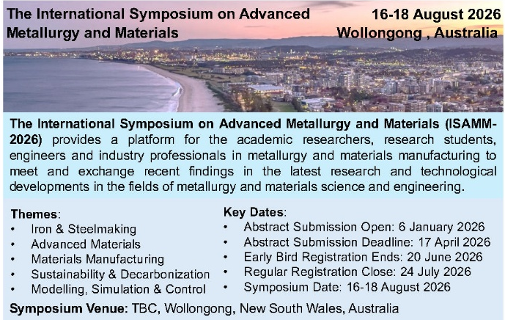
Figure 1. An example of a figure
Table 1. Important dates for ISAMM-2026.
Date | Activity
January 6, 2026 | Call for Abstract Opens
June 20, 2026 | Early-Bird Registration Close
July 24, 2026 | Regular Registration Close
August 16-18, 2026 | Conference Date

Equations are centred and numbered with equation numbers in parentheses flush right, as in Eq. (1). Use either the Microsoft Equation Editor or the MathType add-on for equations in your document. An example is given below,
$$A=πr^{2}$$ | (1)
In the text, cite literature in author-year format, e.g. [Author, 2006], [Author 1 and Author 2, 2016], or [Author 1 et al., 2017]. List all references at the end of the paper in alphabetical order. Use Times New Roman 9 pt for the References section.
References
1. Aguilar O., Perry S. J., Kim J.-K. and Smith R. Design and Optimization of Flexible Utility Systems Subject to Variable Conditions, Part 2: Methodology and Applications, Chem Eng Res Des, 85, 1149-1168, 2007.
2. Bruno J. C., Fernandez F., Castells F. and Grossmann I. E. A Rigorous MINLP Model for The Optimal Synthesis and Operation of Utility Plants, Chem Eng Res Des, 76, 246-258, 1998.

